FEDERAL TRANSIT ADMINISTRATION’S (FTA)

DRUG AND ALCOHOL MANAGEMENT INFORMATION SYSTEM (DAMIS)

INTERNET REPORTING User Manual

Sign into https://Damis.dot.gov

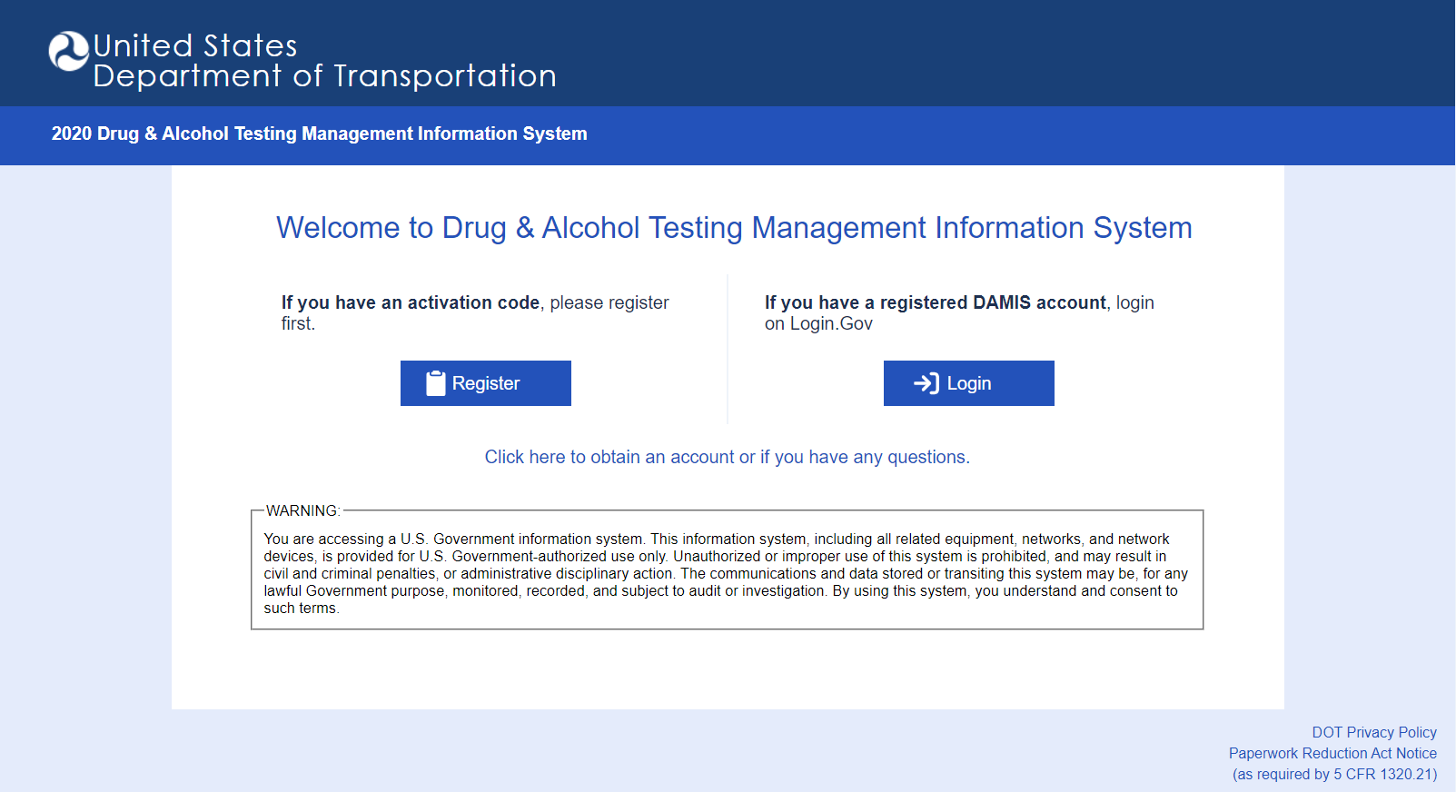

First time users will click “Register” (for reporting year 2023, everyone will need to register a DAMIS account with Login.gov). Enter the activation code from the notification letter or invitation email.

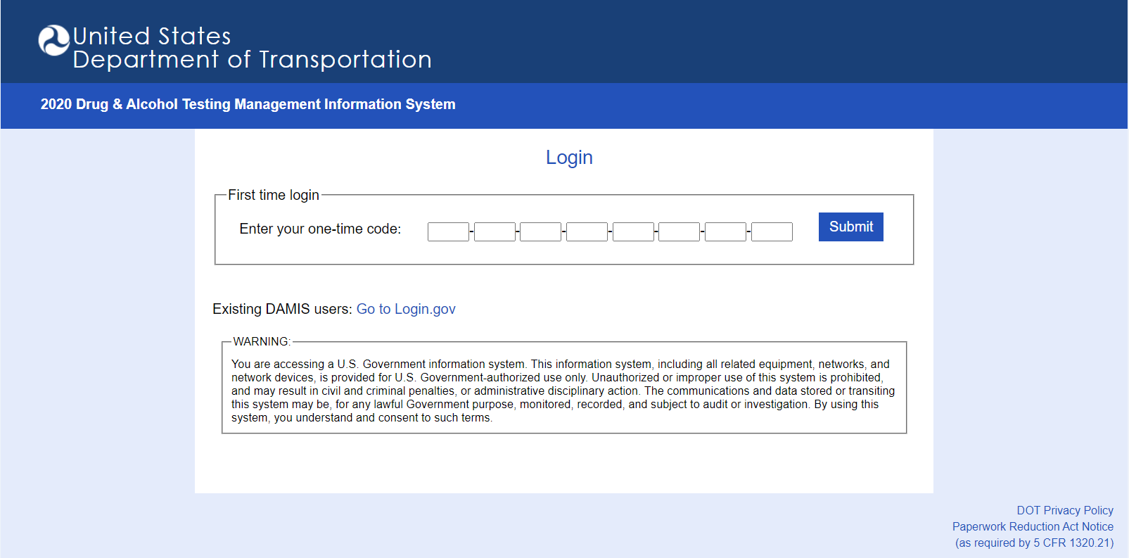

Once the code is entered, click “Submit”. This will bring you to the https://Login.gov screen.

If you already have a Login.gov account, choose “Sign in”. Once you have signed into your Login.gov account, you will be brought back to your DAMIS company page where you may start entering your data.

If you do not have a Login.gov account, click “Create an account” and follow the steps below.

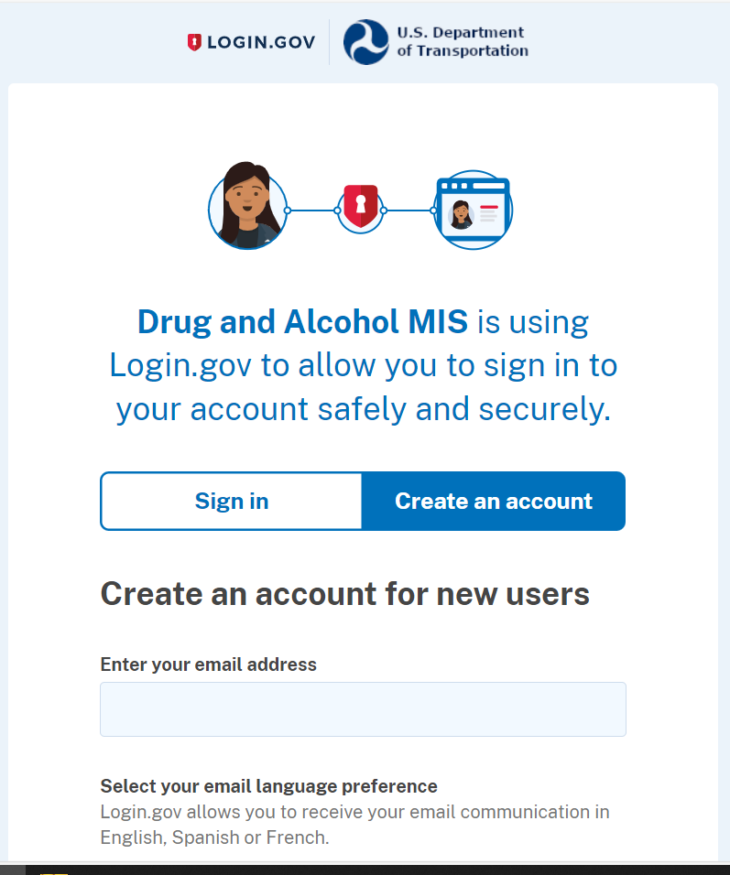

Once an account is created, you will see the following screen directing you to check your email for the confirmation code. This email will be from Login.gov.

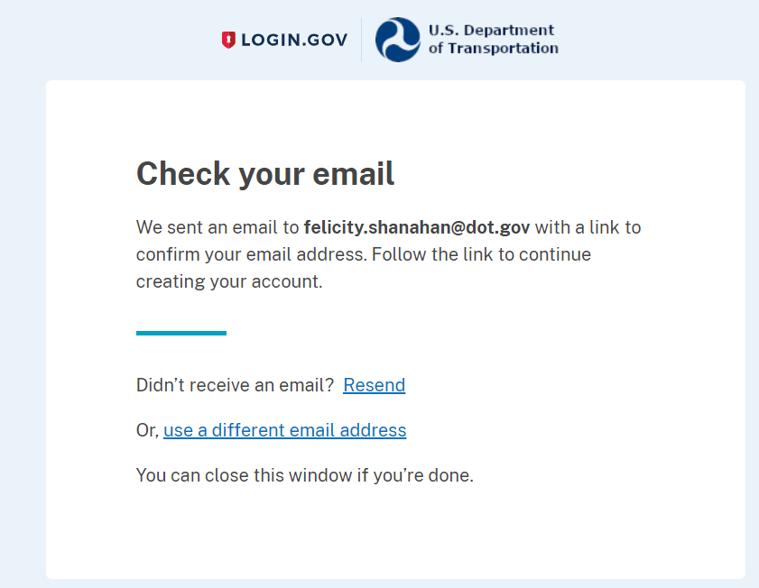

The confirmation email will look similar to the screenshot below.

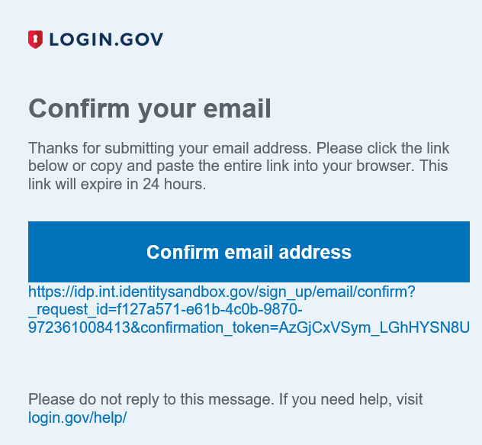

Once the email is confirmed, you will be asked to create a password for Login.gov.
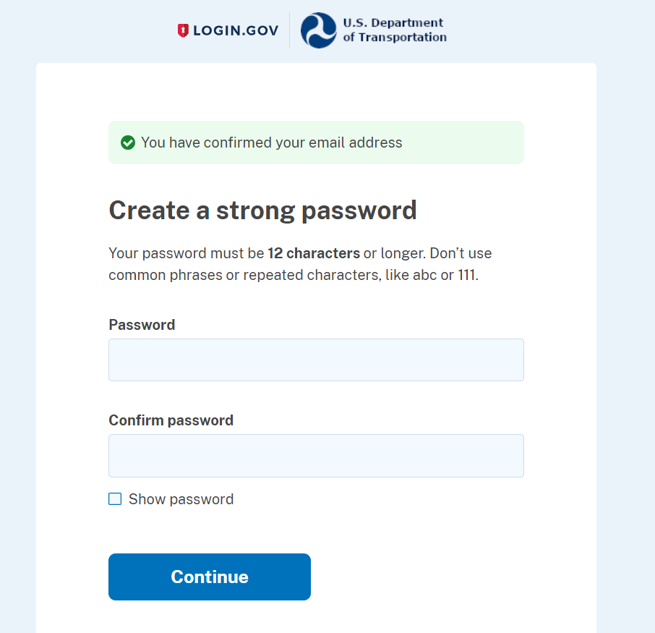

After your password is set, you will be asked to select a second authentication method. Follow prompts depending on the method chosen.

**If you choose “Backup Codes” as your validation method, be aware that once this list of 10 codes has been exhausted, you will no longer have access to your Login.gov account. Your account will need to be deactivated and reactivated by Login.gov and you will need to re-register your account with DAMIS. You may request an additional list of “Backup Codes” from Login.gov before you use the last code.
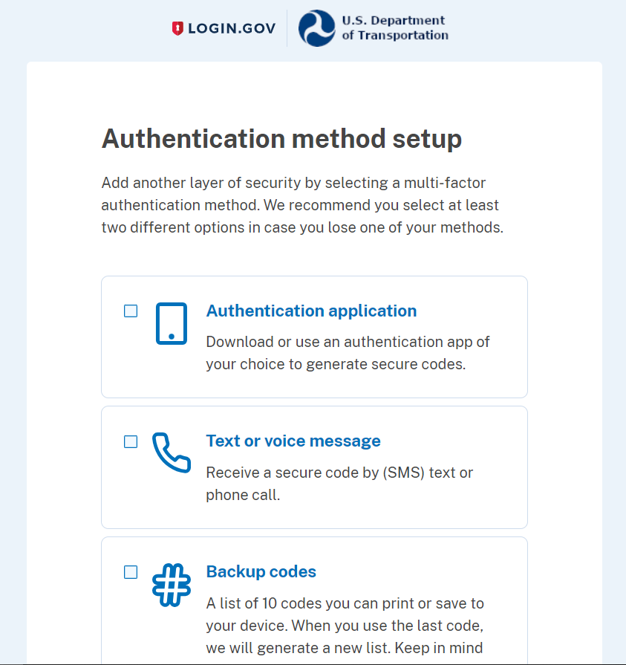
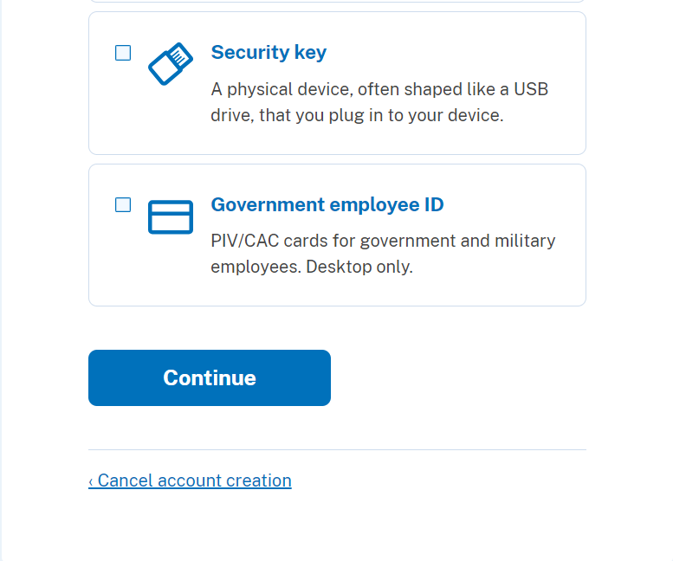

You may choose to add an additional authentication method, or you may skip this and set it up later.
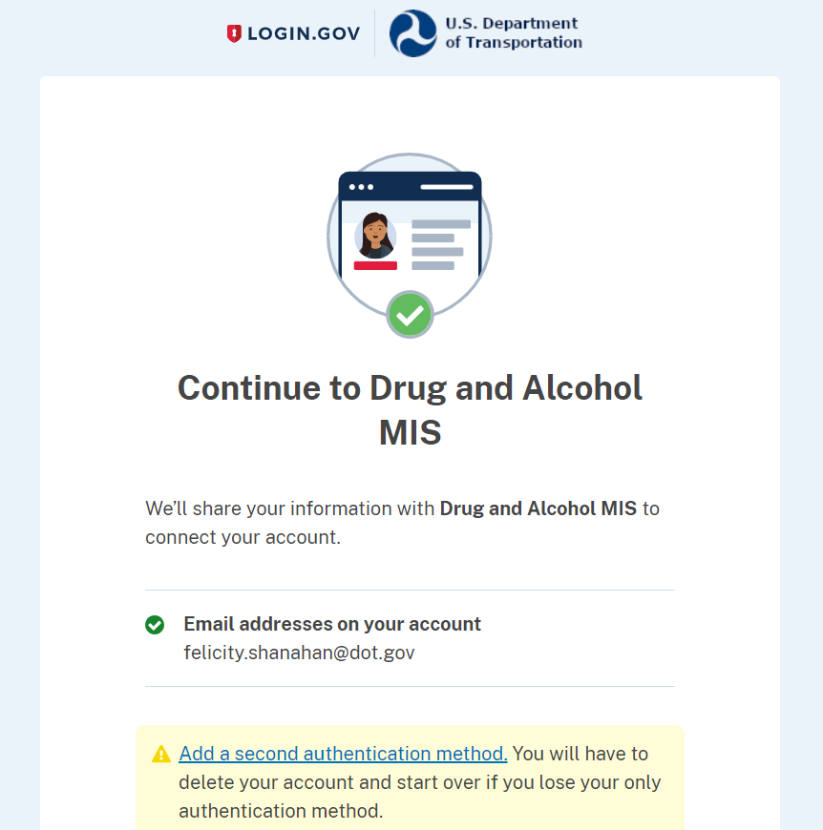
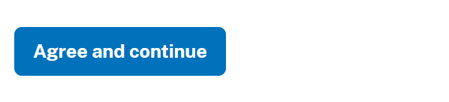
After you click “Agree and continue”, you will be redirected to your company reporting page in DAMIS.

If you are a grantee, FTA will provide your 32-digit activation code in a letter sent to the “Certifying Official” as provided in the previous year’s MIS. As a grantee, once you have logged in, you will see the list of subrecipients and contractors associated with your company. If you require updates to this list, contact the FTA Drug and Alcohol Project Office at FTA.DAMIS@dot.gov or 617-494-6336. As the grantee, you will need to enter an email address for each of your subrecipients and contractors.

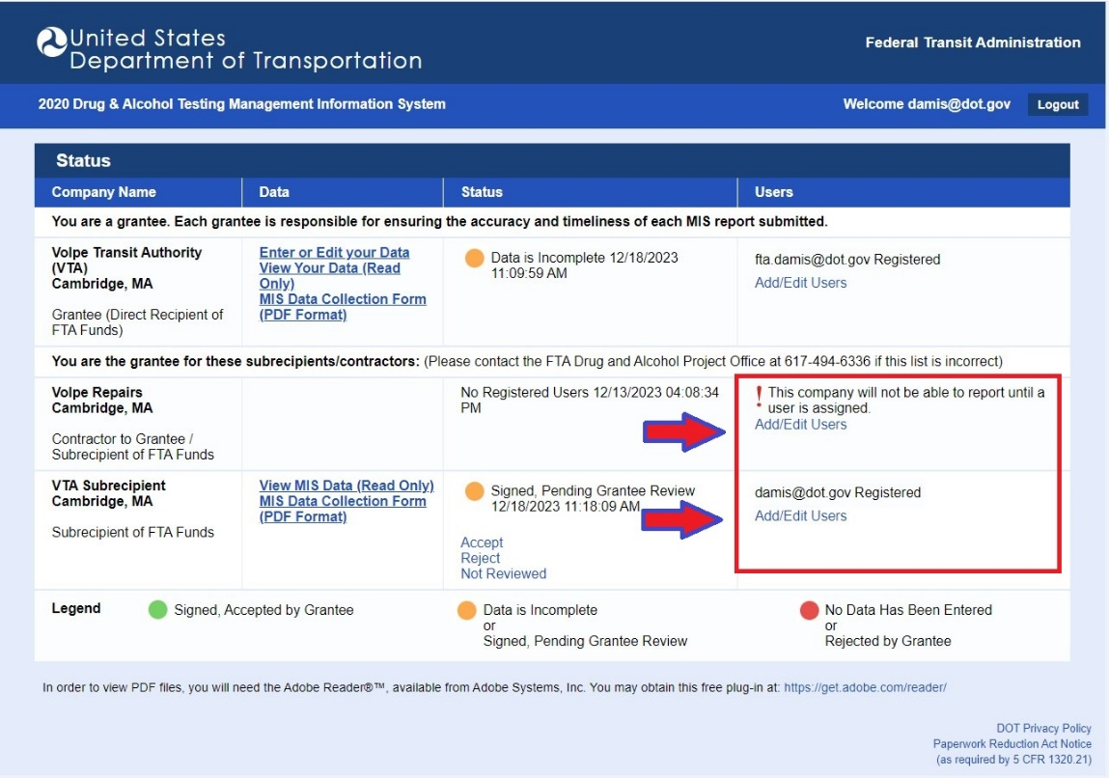

Note: If you are a contractor/subrecipient, the grantee will enter your email into DAMIS and you will receive an email with your 32-digit activation code.

Status Page

You are now on the Status page. The status column shows the standing of your data submission. The table below provides status descriptions of an employer’s MIS data.

Note: If you are a grantee, you will see your own status as well as the status of your contractors/subrecipients.

Status | Description
No Data Has Been Entered | The employer has not begun entering their data.
Data is Incomplete | The employer has logged in, but has not completed entering and/or electronically signed their data.
Signed, Pending Grantee Review | The employer has finished entering their data and has electronically signed their submission. The grantee has not yet reviewed the data.
Signed, Accepted by Grantee | The employer has finished entering their data and has electronically signed their submission. The grantee has reviewed and accepted their data.
Rejected by Grantee | The grantee has found a problem with the data. The employer and the grantee must discuss the problem, then the employer must correct any problems and re-sign their data, and the grantee must review and accept it.

Below is the list of options under the “Data” column and a description of each option.

Data Column | Description
Edit or Enter Your Data | Click to begin entering data
View Your Data (Read Only) | Select to view data previously entered
MIS Data Collection Form (PDF Format) | Download completed data on the U.S. DOT Drug and Alcohol Testing MIS Data Collection Form
Notification Letter | Download a copy of your notification letter (once you have used the 32-digit activation code to register your account, it is no longer valid).

To start entering your data, click on “Edit or Enter Your Data”.

Helpful Hints:

- Context-related help is accessible by clicking on the icon.
- After 15 minutes of inactivity, your browser will time out and you will be required to log in again to continue entering your data. Prior to timing out, all data entered is saved.
- If you have questions about the Internet reporting process or any regulatory questions, please call the FTA Drug and Alcohol Project Office at (617) 494-6336 or email FTA.DAMIS@dot.gov.

Employer Information

Enter or edit the appropriate information in the fields provided.

Note: An asterisk marks a required field; a section is complete once you populate all required fields. When a section is complete, a green check mark (√) will appear on the section tab at the top of the page.

To advance to the next section, click the Covered Employees tab at the top or bottom of the page.

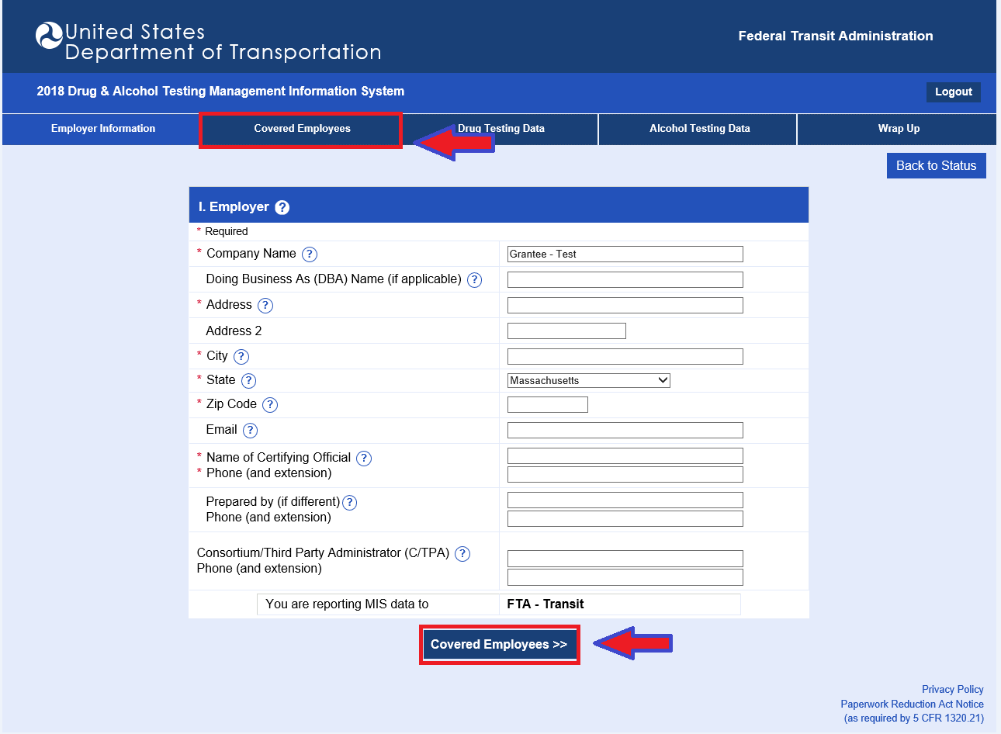

Helpful Hint:

- You can navigate to any section at any time by clicking on one of the corresponding tabs at the top of the screen.

Covered Employees

Enter the number of covered employees in the appropriate employee category. Determine the number of covered employees by averaging the number of the employers’ covered employees in the random testing pool for the calendar-reporting year. (Example: If you perform monthly random selections, add the number of your employees in the random testing pool for each of the 12 months and divide by 12). You must enter a zero for any employee category for which you did not have covered employees in order to complete the section.

Helpful Hint:

- Click the icon next to “II. Employees Subject to Testing” for assistance in determining the number of covered employees.

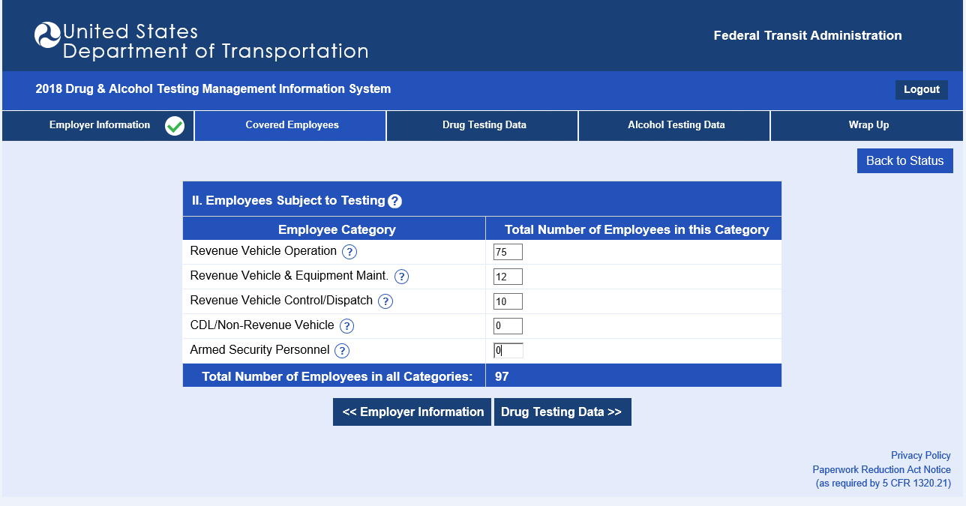

To advance to the next section, click the Drug Testing Data tab at the top or bottom of the page.

Drug Testing Data

Begin with Column 2 (Column 1 is the sum of columns 2, 3, 9, 10, 11, and 12, and will be automatically totaled). Enter data in the appropriate testing categories provided.

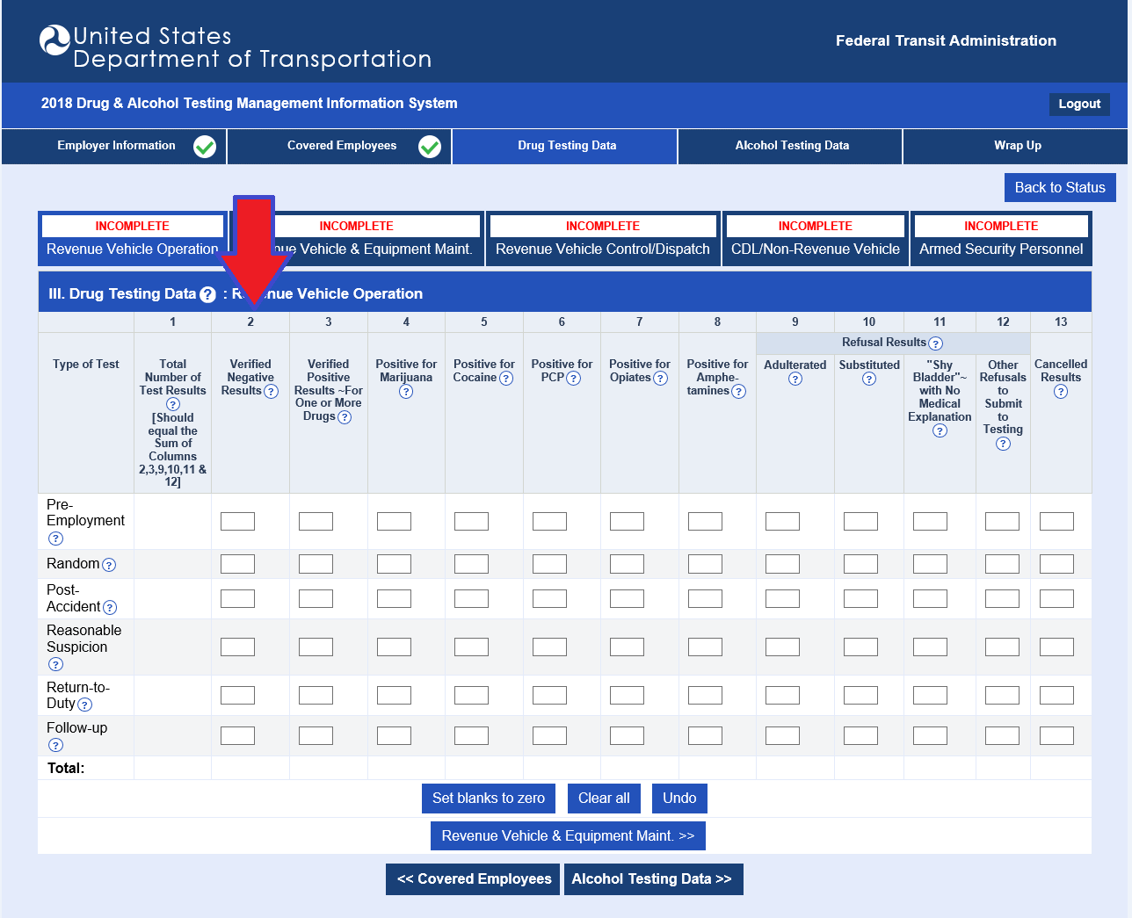

Enter all drug testing data for each test type (Pre-Employment, Random, Post-Accident, Reasonable Suspicion, Return-to-Duty, and Follow-up) performed during the reporting year for each employee category.

Advance to the next employee category by clicking the appropriate tab at the top of the page, or by clicking the employee category button near the bottom of the page.

You must enter a value in each field in order to complete this section.

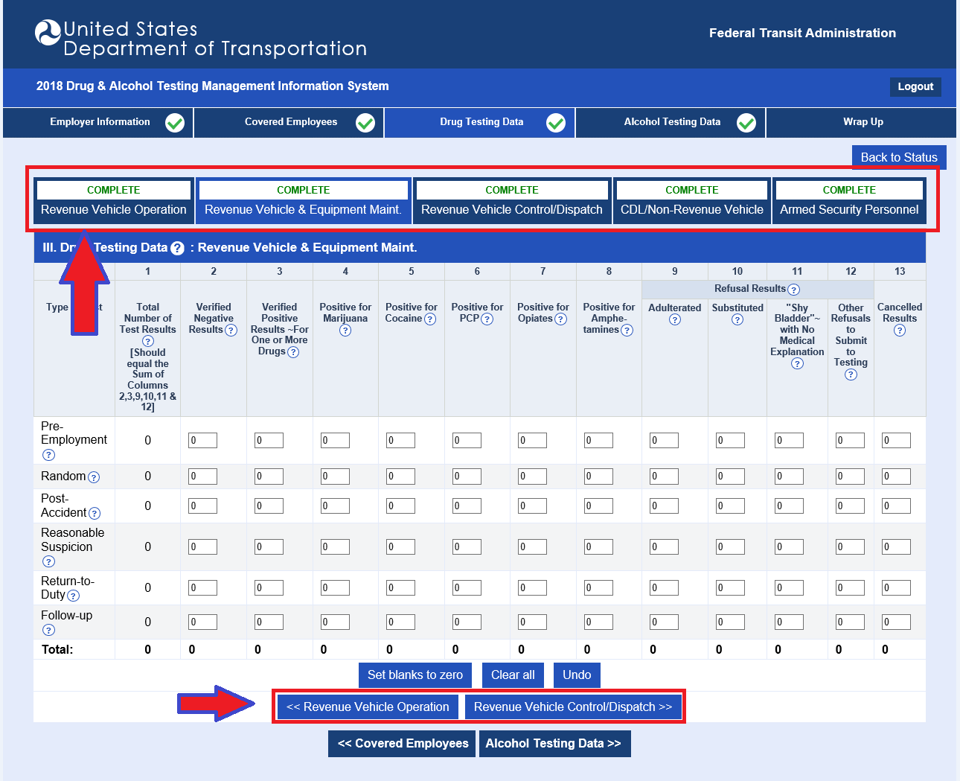

Helpful Hints:

- There are three buttons at the bottom of the drug testing data table: Undo Changes, Clear All, and Set Blanks to Zero. Clicking Undo Changes will revert all fields to their original values. Clicking Clear All will completely clear all fields on the screen, leaving them blank. Clicking Set Blanks to Zero will enter a zero (0) in any blank field.
- Zeros entered in the Covered Employees section will automatically fill into the testing fields for that employee category. You must still proceed to each employee category to accept.

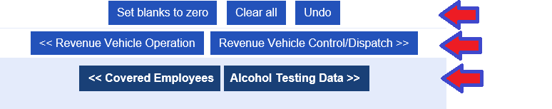

To advance to the next section, click the Alcohol Testing Data tab at the top or bottom of the page.

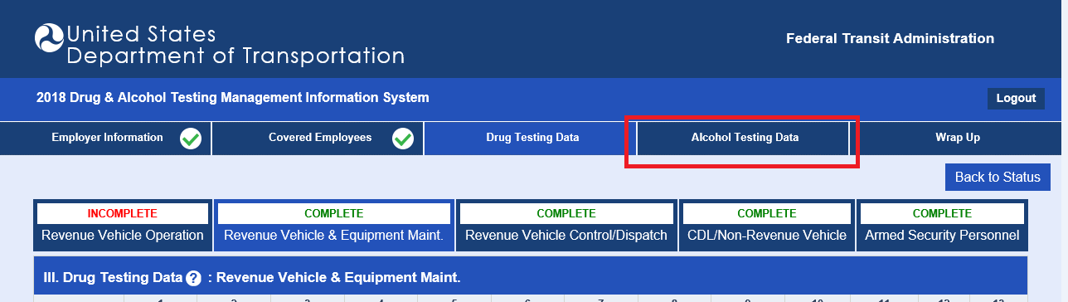

Alcohol Testing Data

The Alcohol Testing Data section is similar to the Drug Testing Data section. The same directions apply for entering data for each of the six test types conducted for each of the five employee categories. You must enter a value in each field in order to complete this section.

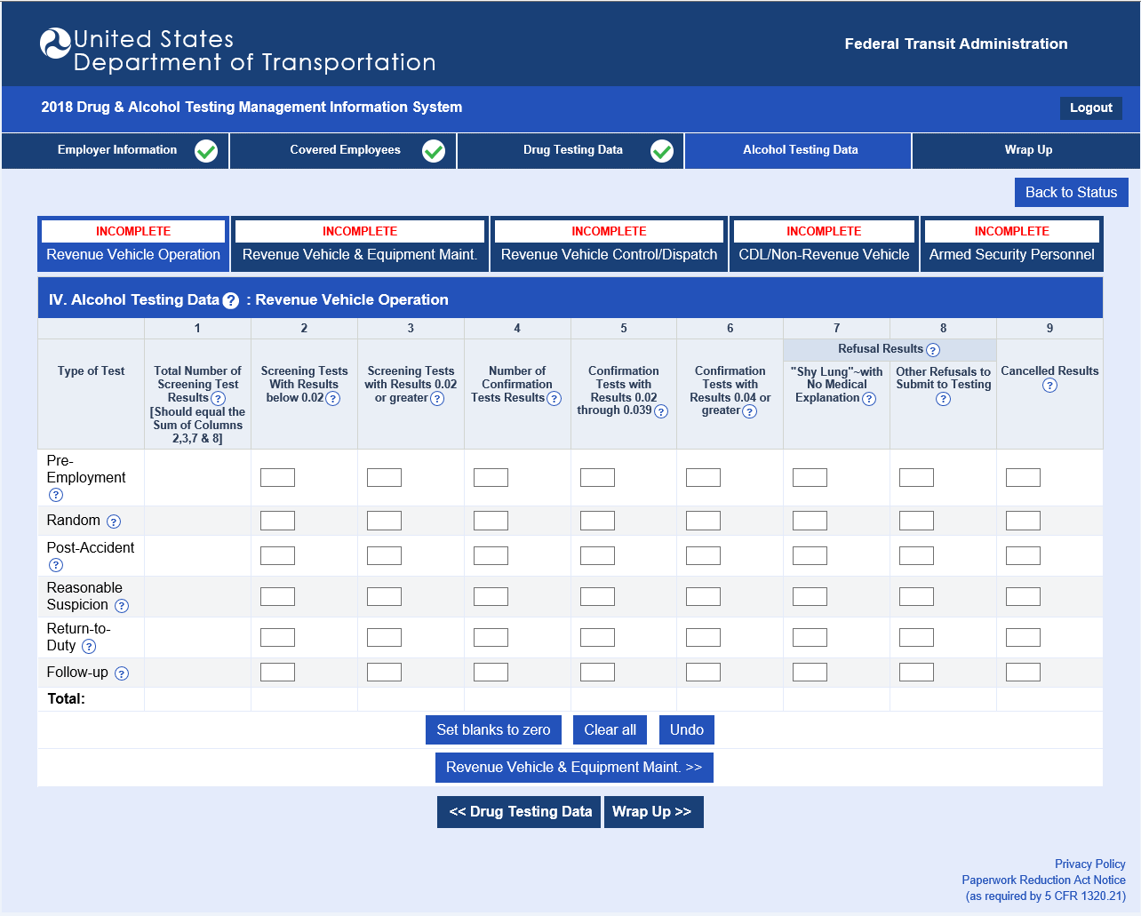

Reminder: Zeros entered in the Covered Employees section will fill zeros into the testing fields for that employee category. You must still proceed to each employee category to accept.

To advance to the next section, click the Wrap Up tab at the top or bottom of the page.

Wrap Up

Helpful Hint:

- Incomplete sections will prompt the following message: You have not finished entering your data. Please click the following button(s) to return to any incomplete section(s).

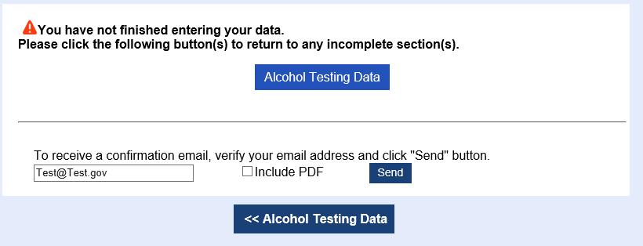

Validation checks run against the data entered. Items flagged by the validation checks will have a button to the right of each error or data check message linking directly back to that section.

Validation Checks | Description
ERROR | You must correct any data Error before electronically signing your data.
DATA CHECK | Review all “questionable” data that triggers a Data Check message. Verify the data entered and make corrections if the information is incorrect. If the data entered is correct, you do not need to change it.

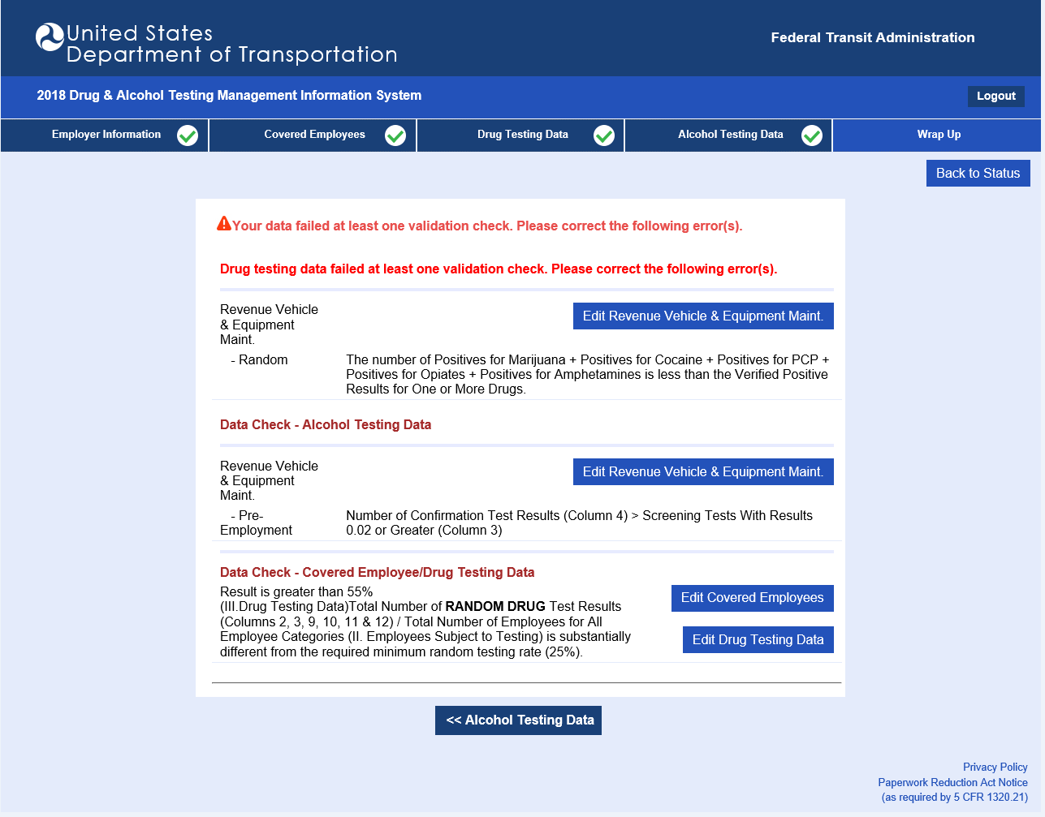

Clicking the Sign and Submit button at the bottom of the page will complete the reporting process.

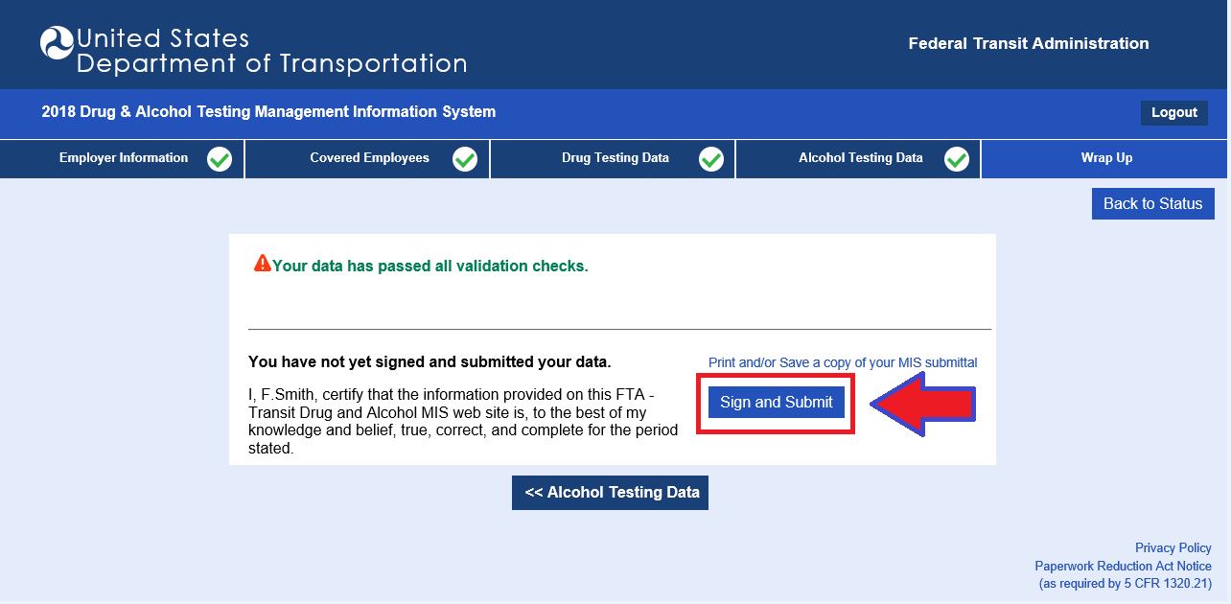

Helpful Hints:

- Confirm the email address listed and click the “Send” button to receive an email confirmation of your data submission. Check off the “Include PDF” box to include a PDF attachment with the confirmation email.
- To download your completed data and view it in Adobe Reader as it would appear on a U.S. DOT Drug and Alcohol Testing MIS Data Collection Form, click Print and/or save a copy of your MIS submittal.

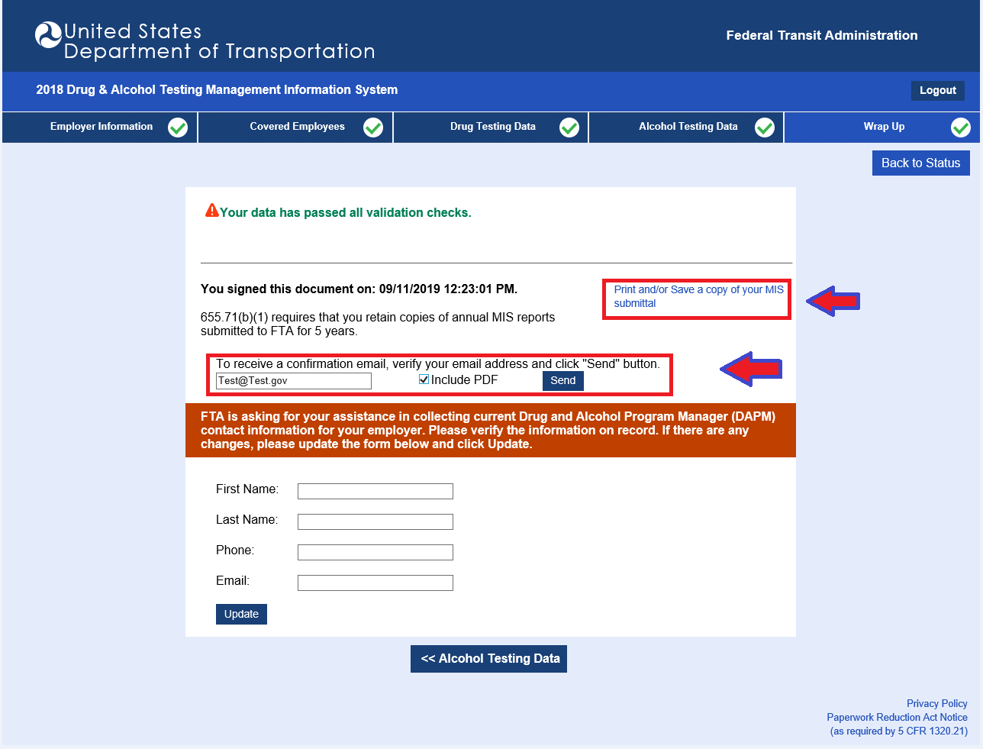

Note: Be sure to print/save a copy of your submission. You are required to retain copies of your annual MIS reports for at least five years.

DAPM Information

Enter the name and contact information for your employer’s Drug and Alcohol Program Manager (this section is optional).

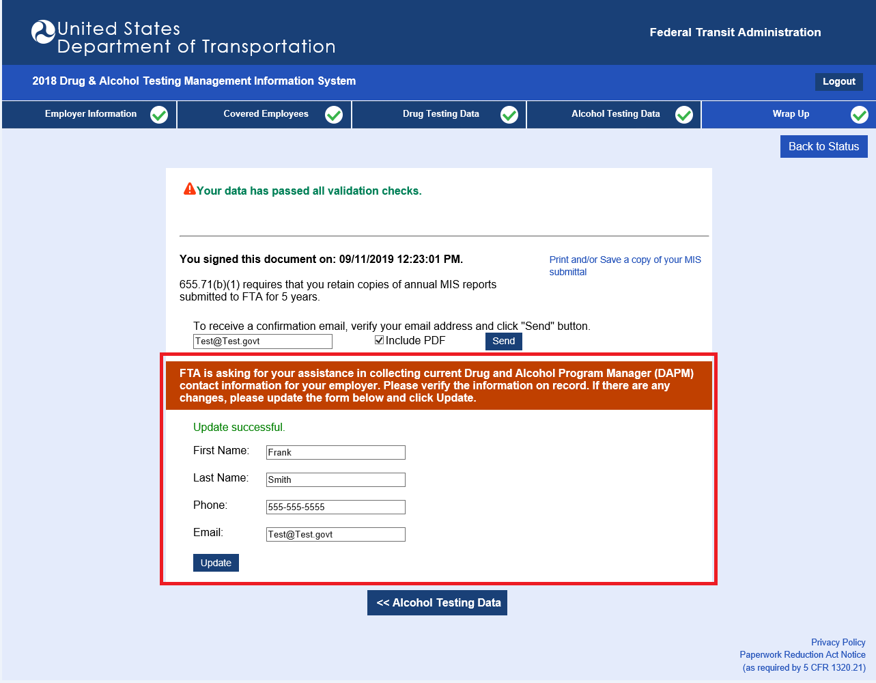

Reviewing Contractor/Subrecipient Data

Grantees are responsible for reviewing data submitted by their contractors/subrecipients and either accepting or rejecting it.

On the Status Page, for each contractor/subrecipient, click “View User Data (Read Only)” to view the data. If the data reviewed is correct, click “Accept”. If the data reviewed is incorrect, click “Reject” and contact your contractor/subrecipient to discuss the issue. The contractor/subrecipient should correct any problems and re-sign their data, and the grantee must review and accept it.

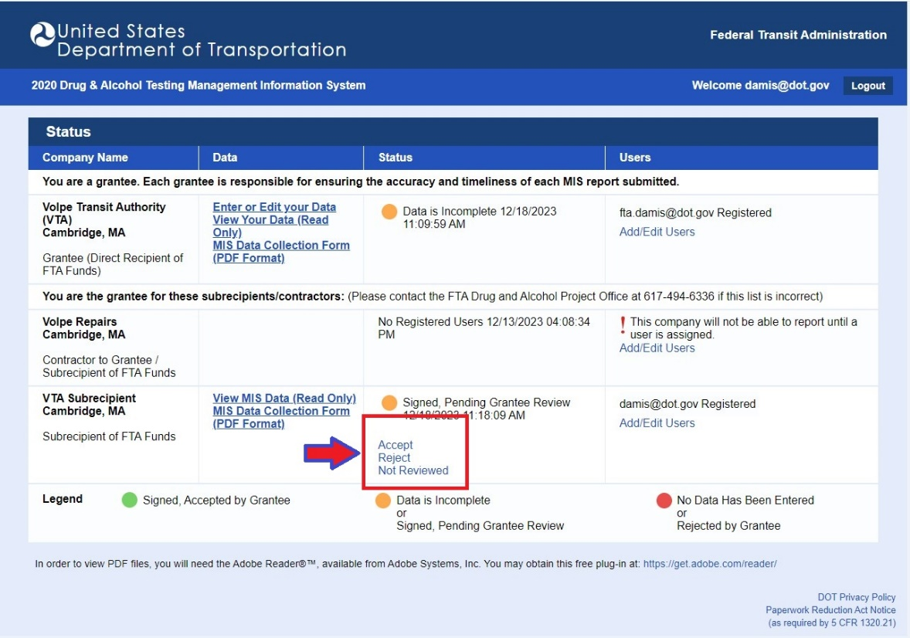

Note: You may sign back in at any time. If you choose to edit your data, you must return to the Wrap Up section and sign your submission again.

Thank you for reporting your drug and alcohol results using the U.S. DOT’s Drug and Alcohol Testing MIS online reporting application. If you have any questions about the reporting process, please call (617) 494-6336 or email FTA.DAMIS@dot.gov.

